
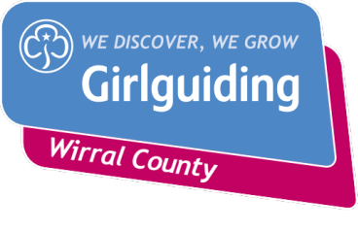
Christmas Cracker at Hadlow Fields

Sat 24th / Sun 25th November 2018

A festive fund raising event for Hadlow Fields, the Girlguiding Wirral campsite.
For Rainbows, Brownies and leaders

Activities: to include from a list of
Make Christmas crafts Decorate Christmas biscuit
Carols by the campfire, with hot drink Write a letter to Santa
Crackers Games- Christmas themed games Make a Christmas Wish
Santa’s Grotto – gift and photo opportunity Listen to Christmas Story

Rudolph’s Den – pocket money gifts (girls to bring extra money)


Cost: (inc coach, all activity costs, drinks, etc)
£15 per girl

Travel via bus/coach:
Units picked up and returned to designated meeting points. Coaches will depart on time.

Place……………………………………………………………………… Time………………………………………………….
General info
- Be at meeting point 15 mins before departure
- After very cold and wet weather at previous events, we’ve hired marquees; girls must still be dressed appropriately as below. Cold and wet kids are no fun
- Full Uniform, with vest, t-shirt under plus hoodie/jacket and trainers/wellies and 2 pairs warm socks, warm waterproof coat, hat, scarf, gloves as the majority of activities are outdoors. We’ve had frosty temperatures in previous years.
- A backpack/rucksack with name on to take home craft items
- Further info sent nearer the time. Parents will need to complete a full Girlguiding consent form.
- Complete form below, return with £15 to your leader by__________________
----------------------------------------------------------------------------------------------------------
I would like (Girls name)………………………………………………………………………………………… to go to
Christmas Cracker at Hadlow Fields.
I enclose £15 and will complete a full Girlguiding consent form nearer the time

Signed………………………………………………………………………………….Parent/Guardian
Date………………………………………………… Tel No…………………………………………………………….

