Thank you for your support.  All money will go towards Hadlow Fields.  These items will be ready for collection from Hadlow on Sat 7th Dec  or delivered to you in time for Christmas for you to enjoy.  Name ………………………………………………………Phone Nos …………………………………….  Address …………………………………………………………………………………………………………..  Amount enclosed …………………… (Cheques to: GGW Hadlow Fields Management)  Please send your order to arrive no later than 8th November to:  HADLOW HAMPERS, 16 Lyndhurst Road, Meols, Wirral CH47 7BP | Girlguiding Wirral’s  Christmas Hampers and Treats    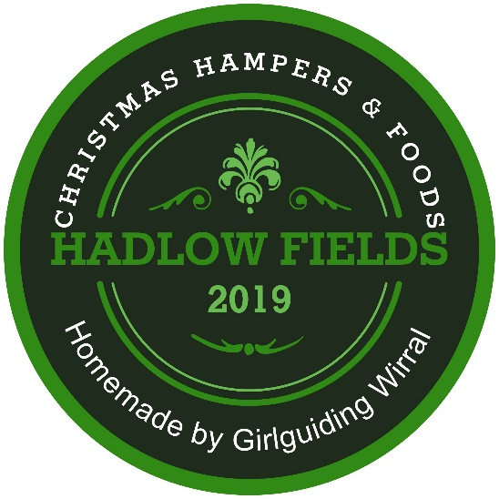  Order your Christmas Hampers and Treats to enjoy yourself  or to give as gifts for Christmas. Homemade for you, by us.  We have some new additions for you to try this year.  Your order will be ready for collection from Hadlow  on Saturday 7th December between 10am and 1pm.  Choose your own selection of our Christmas goodies to make this Christmas extra special.  
  Carried forward from previous page
  Nos | Individual items | COST
  ……………  ….………..  ……………  ……………  ……………  …………… | …………………………………………………………  …………………………………………………………  …………………………………………………………  …………………………………………………………  …………………………………………………………  …………………………………………………………  TOTAL | …………  …………  …………  …………  …………  …………  ______

