Preserves & Christmas Treats  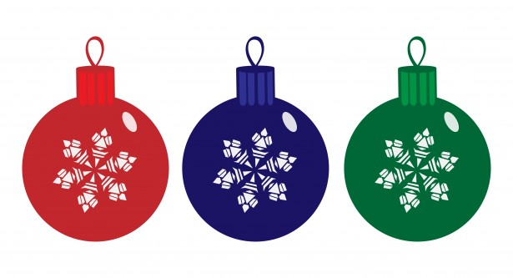  £3.50 each  Jams & Preserves | ORDER FORM 
 | Hampers | Choices | Cost
Our jams are homemade using fruit locally grown on the Wirral.  Seville Orange Marmalade Gooseberry & Lime Marmalade  3-Fruit Marmalade Rhubarb & Ginger Jam Damson Jam  Rhubarb & Strawberry Jam Raspberry Preserve Plum Jam  £3.00 each  Chutneys | Preserves Hamper £10  This includes your choice of any 3 Jams / Marmalades
Each Chutney has its own distinctive flavour, great with meats or cheese.  Spiced Plum Chutney Sweet Pepper Chutney Ratatouille Chutney  Pear & Walnut Chutney Caramelised Onion Chutney  £3.50 each  Christmas Additions | Chutney Hamper £14  This hamper contains one of each of the five chutneys just perfect for chutney lovers.
These homemade additions are the perfect accompaniment to complete your Christmas meals  Cranberry & Port Sauce Crab Apple Jelly  Christmas Mincemeat  Cakes, Truffles & Treats | Christmas Treat £25  Includes a Christmas Cake, one jam of your choice, one Christmas Addition, and Truffles
Nothing is more certain to please, than a slice of traditional Christmas cakes, or even a Truffle or two.  Decorated Christmas Cake Chocolate Truffles  £17.50 10 for £3.50  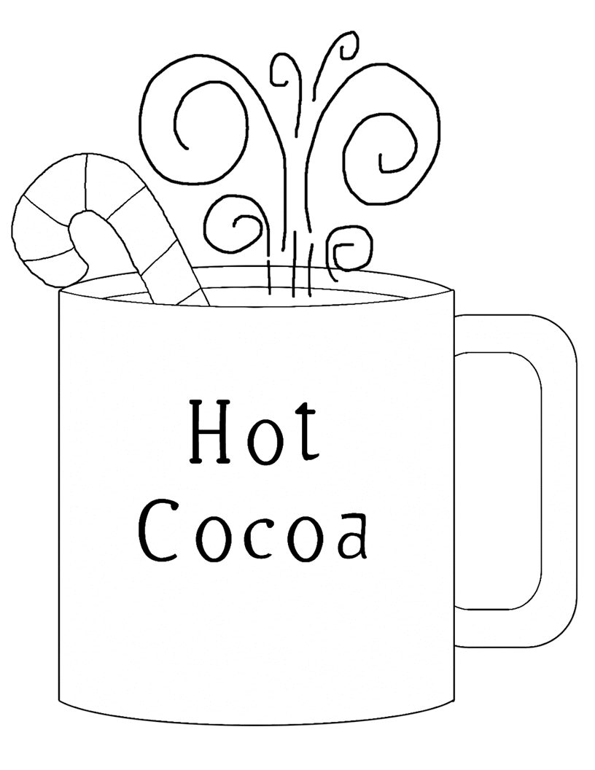  Hadlow Chocolate Mug £6  (Hadlow Mug filled with Drinking Chocolate  Mini Marshmallows & Candy Cane) | Christmas Bonanza  Hamper £30  In this hamper, you get a Christmas Cake, your choice of two Jams, two Chutney, one Christmas Addition and Truffles
All items may be purchased individually or why not choose one of our special Hampers, gift packaged just ready to give to friends or family at Christmas.  We will happily replace any item with anything of the same value. | Hadlow Treat £11  One jam or marmalade, one chutney and a Hadlow Chocolate Mug
 | Total carried over

