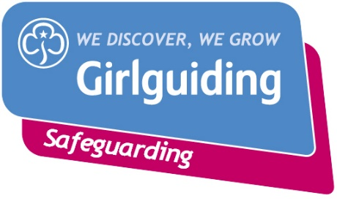
Risk assessment form

Event/ Activity (brief description): |  |  |  |  | Date:
Leader in Charge: | Numbers Attending: |  | Adults: |  | Girls/Young Women: |  | General Public:
Consent for Event/ Activity forms completed:  Yes No N/A |  |  | Venue: |  | Instructor qualification checked*  Yes No
Hazards  What could cause harm or damage? | Who or what is at risk of being affected and how? |  | What are you already doing?  How have you reduced the risk already? |  | Likelihood of risk occurring  (L/M/H) | Severity of Risk  (L/M/H) | Are further controls necessary? What else needs to happen to reduce the risk to an acceptable level? | Action by:  name/date

Decision: once all the actions are carried out, can you manage the risk and go ahead with this event or activity? |  | Yes
(ie have a degree of challenge and risk whilst keeping girls safe) |  | No
If you answered 'no' to the above 'Decision'
questions please explain why:

Risk Assessment completed by: | Date
insert name and role | completed:
 |  | Yes
Has the Risk Assessment been shared with the leadership team? |  | No
Risk Assessment due for review: insert date (no more than 12 months time) | Date:

Risk assessment form

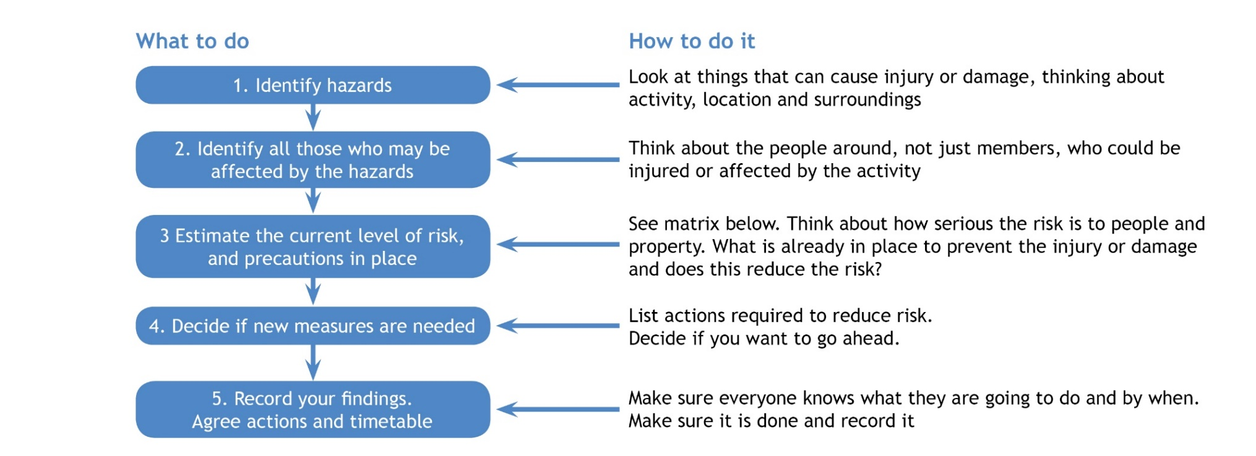

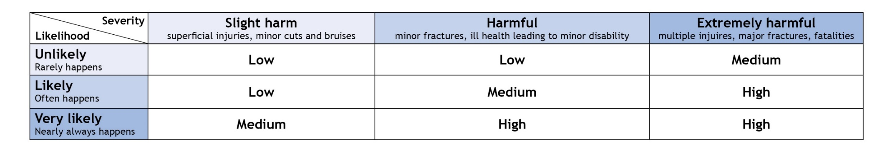

Adults refers to adult volunteers who are part of the team delivering the event or activity *Refer to the activities finder for information about instructor qualifications

