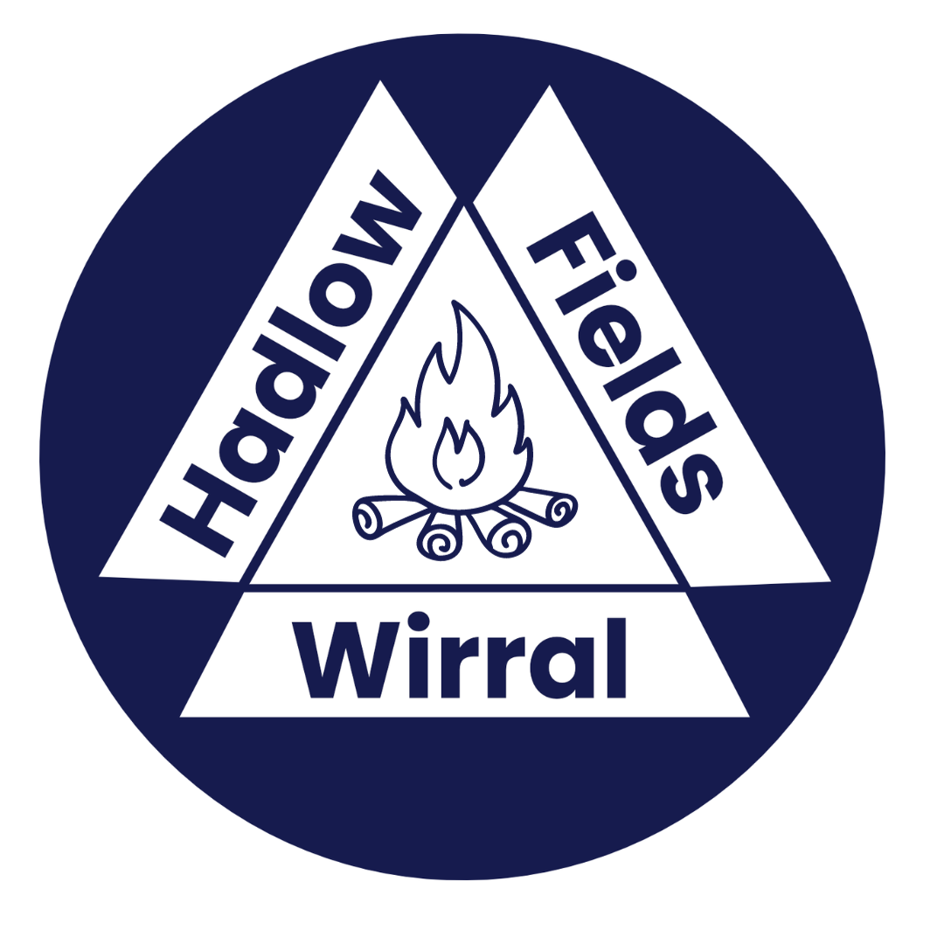

Girlguiding Wirral Hadlow Fields

Equipment Booking Form

Please ensure all bookings are made 2 weeks in advance of the event

LEADERS NAME

UNIT/SCHOOL/GROUP NAME

DISTRICT/ DIVISION /COUNTY

CONTACT ADDRESS INCL POSTCODE
TEL / MOBILE NUMBER |  |  | EMAIL ADDRESS

PLEASE ENTER THE DATE/S AND TIMES YOU WISH TO BOOK THE ITEMS BELOW

MORNING - 10am -1pm / AFTERNOON 2pm – 5pm or EVENING 5-9pm
 | FROM |  | UNTIL
TIPI STYLE TENTS | DATE: | TIME: | DATE: | TIME:
FIRE LIGHTING BOX | DATE: | TIME: | DATE: | TIME:
DUTCH OVEN SET | DATE: | TIME: | DATE: | TIME:
ONE POT COOKERS | DATE: | TIME: | DATE: | TIME:
HAMMOCKS /TARPS | DATE: | TIME: | DATE: | TIME:
DEN BUILDING KIT | DATE: | TIME: | DATE: | TIME:
CIRCUS SKILLS BOX | DATE: | TIME: | DATE: | TIME:
GAMES STORE | DATE: | TIME: | DATE: | TIME:
SPORTS EQUIPMENT | DATE: | TIME: | DATE: | TIME:
CAMPING EQUIPMENT | DATE: | TIME: | DATE: | TIME:

TIPIS: Girlguiding only Cost £10 per night | NUMBER REQUIRED | PITCHING ASSISTANCE? (Y/N)
2 x FESTY Tents – sleeps 6
2 x SOULPAD Tents – sleeps 8 or ideal as activity tents
4 x COIR MATTING – 2 required per Soulpad
2 x BLAZE CAST IRON STOVE & FLUE (for use in Soul Pad Tent only, hirer to provide own wood only suitable for Rangers with adult supervision)

ACTIVITY EQUIPMENT FOR HIRE (Girlguiding Only)  Sessions are 3hours | REQUIRED?  Y / N

FIRE LIGHTING BOX: £15 per session
10 x flint striker sets, 3 x honey stoves & pans, 2 x bushcookers & pans
DUTCH OVEN BOX: £10 per session
1 x 4 litre cast iron dutch oven, cast iron frying pan, cast iron griddle, tripod & chain, pan trivet & pan lid lifter
ONE POT COOKERS: £10 per session
30 x small solid fuel cooker and one person pots. (alcohol gel or blocks required)
HAMMOCK & TARP BOX: £10 per session or £20 over night
5 x dd expedition hammocks, 5 x dd expedition tarps & ropes & pegs
CIRCUS SKILLS BOXES: £5 per session
juggling bean bags, bucket stilts, Chinese ribbons, spinning plates, diabolos, devil sticks, juggling scarves, juggling clubs, poi sets, pedal go, pogo stick
(some items may be unavailable if being repaired / replaced)
GAMES STORE: £5 per session
giant tower block [jenga], giant connect four, giant pick up sticks, giant ludo, giant dominoes, giant noughts & crosses, giant draughts, giant snakes & ladders, parachutes & games book, 4 x sets grass ski’s
(Some items may be unavailable if being repaired / replaced)
SPORTS EQUIPMENT: £5 per session
Rounders Set x2 (Ball, bats, posts, markers)

TENTS & CAMPING EQUIPMENT | NUMBER REQUIRED | COST PER ITEM
5 X TOILET TENTS |  | £2 Per Night
2 X WASH TENTS |  | £2 Per Night
2 X COLEMAN EVENT SHELTERS |  | £5 Per Day
GROUND SHEETS [VARIOUS SIZES] Please state number required |  | £1 Per Night
3 X EUROHIKE CALDER - SLEEPS 3 |  | £5 Per Night
1 X SUNCAMP DOME - SLEEPS 2/3 |  | £5 Per Night
2 X VANGO ALPHA 250 - SLEEPS 2/3 |  | £5 Per Night
1 X VANGO IGLOO – SLEEPS 2/3 |  | £5 Per Night
EQUIPMENT
4 x DOUBLE BURNER COOKERS – lightweight pans only |  | £5.00 Per Day
SITTERS [VARIOUS SIZES]
COOKING EQUIPMENT, CUTLERY & CROCKERY
PLATES / BOWLS / CUPS [24 PEOPLE] |  | £5 Per Day
KNIFES / FORKS / SPOONS / TEASPOONS [24 PEOPLE] |  | £5 Per Day
CATERING PANS including dixies, flying pans, kettles |  | £5 Per Day

Please note that all equipment must be returned at the end of the period of use in a clean, dry and unbroken condition. A repair or replacement charge will be made for breakages.

Signed: |  |  | Date:

Please return the completed form to Hadlow Fields, Hadlow Road, Willaston, Neston CH64 2UN with Site Booking Form. Or via email: hadlowbookings@girlguidingwirral.org.uk

Equipment requests will be acknowledged within 7days of receipt.

